High Voltage Battery Gauge (SoC) – BEV – CGEA1.3

Functional Description

The purpose of the High Voltage Battery Gauge feature is to inform the driver of the vehicle’s State-of-Charge for the High Voltage Battery.

The Battery Gauge correlates the BattTracSoc_Pc_Dsply, DestSocRqd_Pc_Dsply, BattTracLoSoc_D_Dsply and the Operational Mode to generate gauge level displaying the vehicle’s current State-of-Charge for the battery . The Battery Gauge shall be capable of indicating the maximum State-of-Charge. The raw input is filtered by the cluster for smooth and continuous level indicator movement (this is a slow moving signal, so minimal filtering from the cluster is required).

For the state of Charge (SoC), the Battery shall provide a vertical or horizontal gauge with a colored (Blue or Amber or Red) variable fill pointer on display. The Battery Gauge pointer shall rise from a rest position to indicate increasing state of charge, and fall to indicate decreasing state of charge.

BattTracSoc_Pc_Dsply will decide the battery fill while BattTracLoSoc_D_Dsply will decide the gauge fill color and also the color of battery Symbol. DestSocRqd_Pc_Dsply decides the destination flag position below gauge fill (Refer latest HMI for actual position).

Interfaces

Interface Context Diagram (I/O Block Diagram)
Figure 1 High Voltage Battery Gauge (BEV) Context Diagram

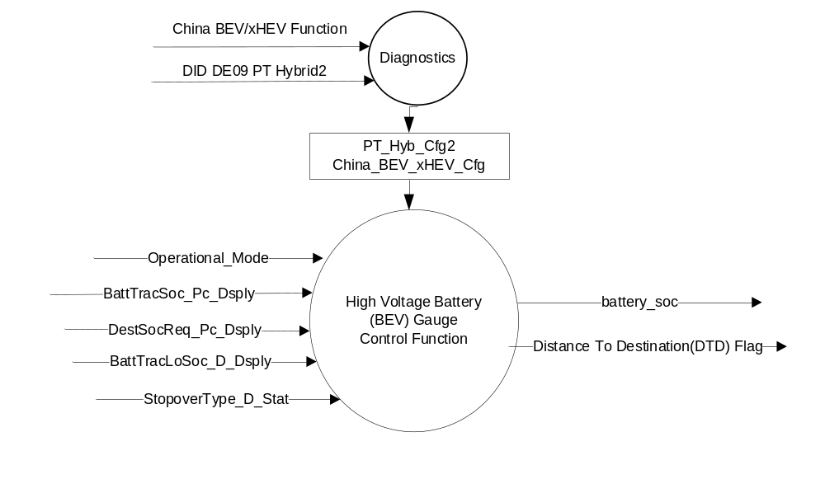

Inputs

- Internal:
- Operational Mode

- MUX message on the CAN Bus

- BattTracSoc_Pc_Dsply Signal
Signal  Name | Size  (bits) | Detail | Units | Resolution | Offset | State  Encoded | Min. | Max.
BattTracSoc_Pc_Dsply | 8 |  | % | 0.5 | 0 |  | 0  (0x00) | 255  (0xFF)

- DestSocRqd_Pc_Dsply Signal
Signal  Name | Size  (bits) | Detail | Units | Resolution | Offset | State  Encoded | Min. | Max.
DestSocRqd_Pc_Dsply | 8 |  | % | 0.5 | 0 |  | 0  (0x00) | 255  (0xFF)

- BattTracLoSoc_D_Dsply Signal
Signal Name | Size  (bits) | Detail | Units | Res. | Offset | State Encoded | Min. | Max.
BattTracLoSoc_D_Dsply | 2 |  | SED | 1 | 0 |  | 0x0 | 0x3
 |  | 0x0 |  |  |  | Null
 |  | 0x1 |  |  |  | LoDte
 |  | 0x2 |  |  |  | ZeroDteDepleted  Battery
 |  | 0x3 |  |  |  | NotUsed_1

- StopoverType_D_Stat Signal
Signal Name | Size  (bits) | Detail | Units | Res. | Offset | State Encoded | Min. | Max.
StopoverType_D_Stat | 3 |  | SED | 1 | 0 |  | 0 (0x0) | 7 (0x7)
 |  | 0x0 |  |  |  | Null
 |  | 0x1 |  |  |  | Final Destination
 |  | 0x2 |  |  |  | Charge Station
 |  | 0x3 |  |  |  | Home
 |  | 0x4 |  |  |  | Work
 |  | 0x5 |  |  |  | Other
 |  | 0x6 |  |  |  | NotUsed_1
 |  | 0x7 |  |  |  | Fault

Outputs
- battery_soc – displayed level of High Voltage Battery Gauge (% fill)
- Distance To Destination(DTD) Flag – Graphical Flag

Function/Performance

Operational Modes

Mode | Differentiating Vehicle Conditions
Sleep Mode | High Voltage Battery Gauge off
Limited Mode | High Voltage Battery Gauge off
Normal Mode | High Voltage Battery Gauge indicator at “High Voltage Battery Gauge”
Crank Mode | High Voltage Battery Gauge indicator at last “High Voltage Battery Gauge” determined in Normal Mode.

Voltage Levels

Refer to the Cluster Features Table located in the Operational Modes and Voltage Range Strategies Section of this SPSS

Human-Machine Interface

Visual

Indicator Graphics / Display Format

High Voltage Battery Gauge Graphics

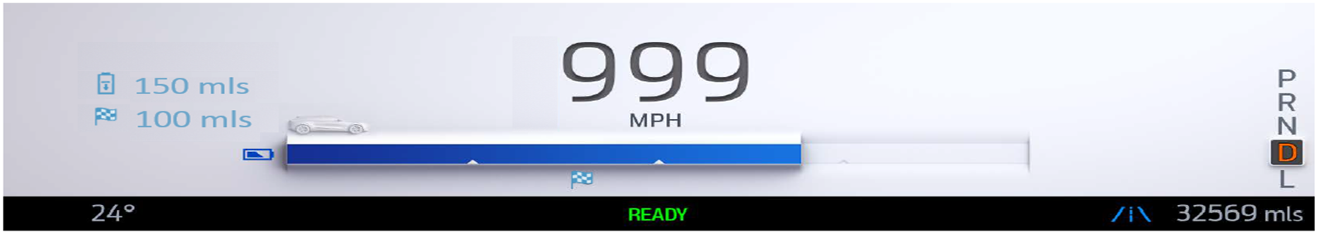

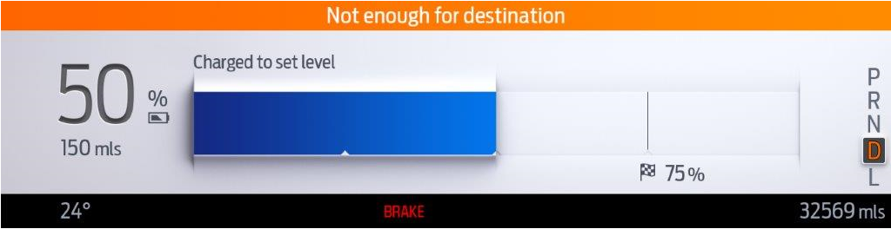

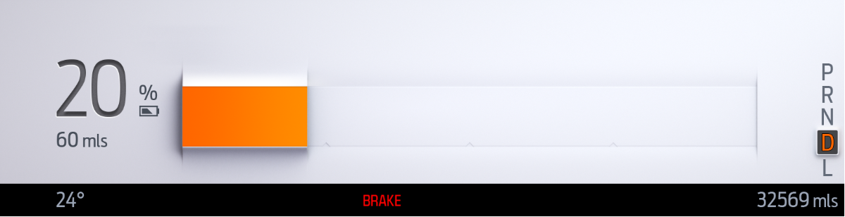

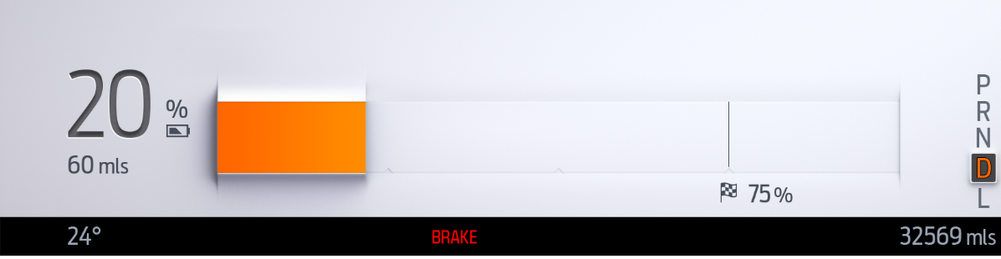

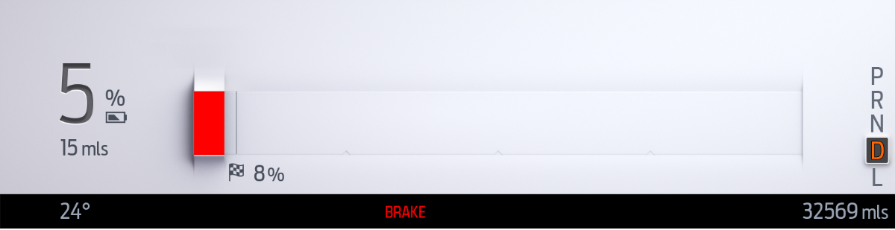
Refer to the Model(s) and specific graphics delivery for the exact Gauge Graphics and ICON graphics.

Indicator Color Coordinates

None

Indicator Characteristics

Audio

None

Switch Control Logic

Not Applicable

System Accuracy

The cluster shall use "battery_soc" to update the High Voltage Battery Gauge pointer position at least 100 msec.

Operation: Performance and Functional

Subsystem Algorithm Flowchart / State Diagram

None

Operation Description

- The IPC shall determine when to display a bar fill gauge or a percentage number for the High Voltage Battery State of Charge based on criteria below:
- IPC shall display Battery SOC fill gauge when all the following conditions are true:
  - ADAS disabled
  - MAP not selected on Cluster View
  - and SDM is in GO mode
- Otherwise Display a Percentage number
- The Battery Gauge shall show empty gauge at max rate when BattTracSoc_Pc_Dsply (CAN) Signal is missing or invalid consecutively for 5 seconds or more.
- Shown Dashes “- -“ when BattTracSoc_Pc_Dsply (CAN) Signal is missing or invalid consecutively for 5 seconds or more if Battery SOC is shown as Dynamic Text. E.g. ADAS or Navigation is active.
- The Gauge shall be initialized to the first valid signal value (0x00 -0xC8) received after:
- A transition to Normal/Crank/Limited from Sleep
- A recovery from the Rest Position for Missing Signals or Invalid values

- The battery fill on screen can be Blue, Amber or Red based on SOC status and it scales from 0-100% for battery state of charge. Gauge color will change based on input CAN signal ‘BattTracLoSoc_D_Dsply .
BattTracLoSoc_D_Dsply = 0 = Blue
BattTracLoSoc_D_Dsply = 1 = Amber
BattTracLoSoc_D_Dsply = 2 = Red
- Its only state of charge gauge and does not represent Range. The range can vary per a given state of charge since the electric range estimate depends on many factors. There will simply be no fill when the battery is at 0% (correlating to 0 mi range).

- Round Down the display value for for BattTracSoc_Pc_Dsply and DestSocRqd_Pc_Dsply.

- Gauge Fill will be 0% to 100% based on BattTracSoc_Pc_Dsply

Battery gauge fill will dynamically update the fill based on BattTracSoc_Pc_Dsply CAN input. BattTracSoc_Pc_Dsply is percentage signal and range from 0% to 100%

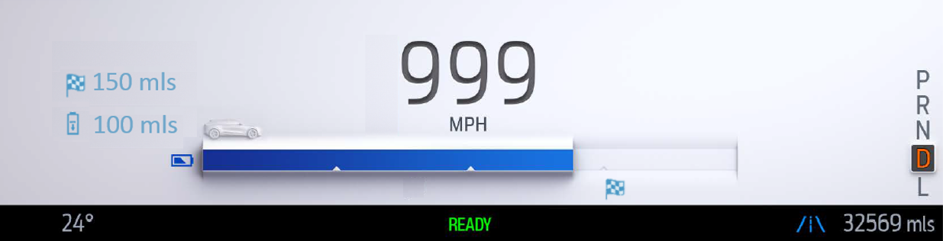

- Gauge Fill color will be changed based on input CAN signal BattTracLoSoc_D_Dsply
BattTracLoSoc_D_Dsply = 0 = Blue
BattTracLoSoc_D_Dsply = 1 = Amber
BattTracLoSoc_D_Dsply = 2 = Red
BattTracLoSoc_D_Dsply = Missing = Blue

- Battery gauge will be displayed as dynamic Text with percentage Fill value if ADAS or Navigation is active on cluster display.

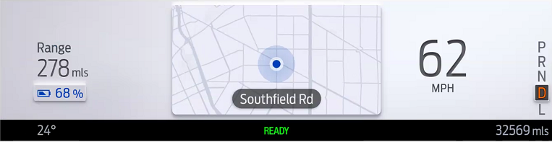

- The Destination Flag will not be shown if vehicle is not in trip and StopoverType_D_Stat = 0x0(No Trip).
Destination flag below battery gauge will dynamically change its position based on destination distance.
DestSocRqd_Pc_Dsply CAN input for this flag is percentage signal and range from 0% to 100%.
There will be no destination symbol if vehicle is Not In Route i.e. StopoverType_D_Stat = 0x0(Null) or StopoverType_D_Stat is missing.

- Battery Symbol changes its color based on input symbol. Fill inside battery symbol is static and does not change with battery SOC.
Battery Symbol on left of battery gauge is static symbol(No Change in Fill) which changes only its color based on Gauge Fill status.
BattTracLoSoc_D_Dsply = 0 = Blue
BattTracLoSoc_D_Dsply = 1 = Amber
BattTracLoSoc_D_Dsply = 2 = Amber
BattTracLoSoc_D_Dsply = 3 = Red
BattTracLoSoc_D_Dsply = Missing = Default (Blue)

- Car Symbol behavior
Car Symbol on top left of battery gauge is a static symbol which neither changes its color not its position. Please refer latest HMI for updated graphics.

- If the IPC is using the HV Battery SOC Gauge display, the IPC shall display the following icon based on the type of destination.

StopoverType_D_Stat | Destination Icon
0x0 (Null) or Missing as per section 1.4.1  (No active route) | None
0x1 (FinalDestination) | 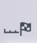
0x2 (ChargingStation) | 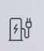

If the IPC is using the HV Battery SOC percentage display the IPC shall not display the icons above.
The icon are only displayed when we have a route set and when the cluster is using the HV Battery SOC
Gauge as a display. Please refer lasted HMI specification for ICON graphics.

- The IPC shall change the HV Battery SOC icon based on IPC DID DE09.

China BEV/xHEV Function Configuration | Battery Symbol
0x1 (China) | 
0x0(Non-China) | 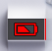
The china symbol is a regulated symbol based on GBT4094.2 2017. The color of the symbol can change based
on BattTracLoSoc_D_Dsply signal.

- If the IPC is using the HV Battery SOC percentage display, the IPC shall display HV SOC based on the following:

- When BattTracSoc_Pc_Dsply == 0 the IPC shall display to zero percentage
- When BattTracSoc_Pc_Dsply > 0 the IPC shall display the value, except when invalid.
- The IPC shall display 2 dashes”--“ for the percentage number when either of the following is true:
BattTracSoc_Pc_Dsply = 0xFE or 0xFF or Missing
- If the IPC is using the HV Battery SOC gauge display, the IPC shall display HV SOC based on the following :
- When BattTracSoc_Pc_Dsply == 0 the IPC shall display an empty gauge per graphics direction which is shown below:
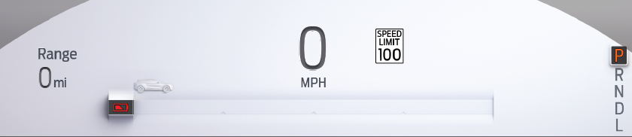
- When BattTracSoc_Pc_Dsply > 0 the IPC shall map the 0% to an empty gauge (shown above) and 100% to a full gauge.
- The IPC shall display an empty SOC gauge when either of the following is true:
BattTracSoc_Pc_Dsply = 0xFE or 0xFF or Missing

Function Safety Classification (EMC)
B

Memory Storage

Parameter Name | Description | Value at  Battery Connect | Value at  Module Wake-up
battery_soc | Used to control the gauge pointer position. | 0 (at Rest Position) | 0 (at Rest Position)
BattTracSoc_Pc_Dsply | CAN signal Battery state of charge (SOC) | As per CAN Message List | Do Not Init
DestSocRqd_Pc_Dsply | CAN signal Destination State of Charge (SOC) | As per CAN Message List | Do Not Init
BattTracLoSoc_D_Dsply | CAN Signal for DTE Status | As per CAN Message List | Do Not Init
StopoverType_D_Stat | CAN signal which indicates the type of stopover location for the Online Trip Planner feature | As per CAN Message List | Do Not Init
Operational_Mode | 4 state indicator for cluster operational mode | Limited | Limited, Normal or Crank

Prove Out
No

Error Handling

The State-of-Charge Gauge shall return to the No Fill within 1000ms of determining an error condition

Missing/Invalid Message Strategy
As determined per missing/Invalid Strategy for signal BattTracSoc_Pc_Dsply.

Diagnostics

Self Test
Not Applicable

Engineering Test Mode
Reference section “Dealer / Engineering Test Mode (ETM)”

Part II Performance
Supported Diagnostic Trouble Codes (DTCs)

DTC | Description | When Logged
C11100 | Lost Communication with Battery Energy Control Module “A” | Missing Message for 5 seconds or more
C29300 | Lost Communication with HPCM | HS_CAN message missing for more than 5 seconds

DID DE09
Block  Num | Block Description | Byte(s) | Bits | State: Description | "0" | "1" | Default | Comments/Information
PACKETED BLOCKS
$09 | Option Content (B&A) | * | * | China BEV/xHEV Function | Not China | China | China | For China (Peoples Republic of China) must be set to China for compliance to China reg GB/T 4094.2-2005. Taiwan MUST be set to Not China.
$09 | Option Content (B&A) |  | 3 | PT Hybrid2(PT_Hyb_Cfg2)  0x0 = Non-Hybrid  0x1 = BEV  0x2 = FHEV  0x3 = PHEV  0x4 = MHEV |  |  | 0x0 | Default from cluster plant to be 0x0 if cluster can be used on a Non-Hybrid.

Reference Specification
None

Revision History
SPSS Module Revision History

Revision Level | Name | Change Description | Date
1.0 | H Sharma | Initial Release :  This  is a new feature brought in DICC by Charbel Bouery on Jan 24th-2019 and approved to create a new spec.  Feature Owner : Charbel Bouery | 1/31/2019
1.1 | H. Sharma | This is minor update to update CAN signal name to match latest CAN Database. ‘DestSocReq_Pc_dsply’ CAN signal is replaced with ‘DestSocRqd_Pc_Dsply’. | 03/13/2019

